**Hult International Business School**

**A2: Marketing Report**

**Parth Ghosh, Elshaday Gezahegn, Madeleine Benna, Yashita Sandhu Othman Bdeir**

**Marketing Analytics - DAT-6033 - SFO1**

**Nabanita Talukdar**

**July 10th, 2025**

# Introduction

Shiva Tourist Dhaba, a well-known highway restaurant on NH24 in Uttar Pradesh, has carved a niche as a hygienic, family-friendly, and affordable vegetarian stopover. Known for its signature Dal Makhni, personal touch from founder Mama Yadav, and smart pricing, it attracts a diverse mix of travelers. But with the rise of branded QSRs and customers has become more challenging.  
  
This report analyzes customer loyalty using SPSS-based Discriminant Analysis and offers strategic recommendations to help Mama Yadav fine-tune his restaurant’s positioning for long-term success.

# Methodology

Customers were classified into three loyalty groups based on visit frequency:  
- Low: 1 visit  
- Medium: 2 visits  
- High: 3 visits  
  
We used Multiple Discriminant Analysis (MDA) to identify which of the 9 positioning variables significantly differentiated these groups. These included Advertisement, Price, Place, Food Quality, Service Quality, Variety, Servicescape, Parking Facility, and Gifts to Drivers.  
  
Discriminant Analysis is ideal because it models the relationship between a categorical dependent variable (loyalty group) and metric independent variables (Likert-scaled perceptions).

# Key Findings from SPSS

1. Tests of Equality of Group Means: All 9 variables significantly differentiate between groups (p < .001).

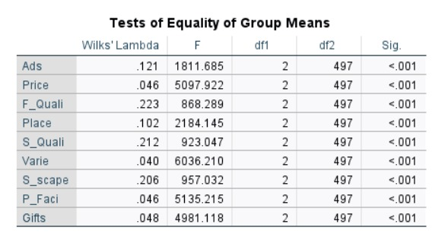

2. Structure Matrix (Function 1 – Loyalty Driver Strength):

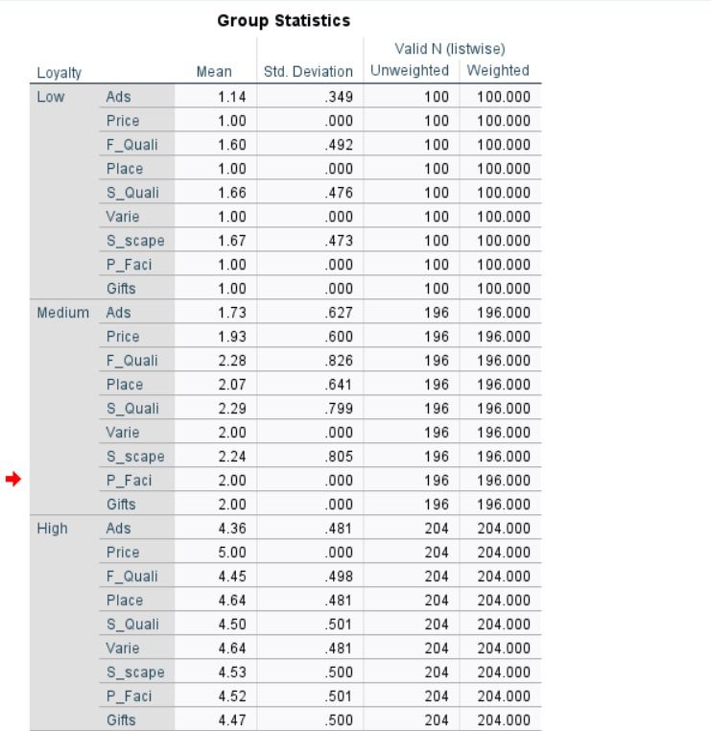

3. Canonical Discriminant Functions:

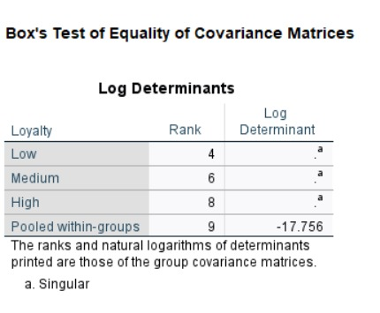

4. Classification Results:

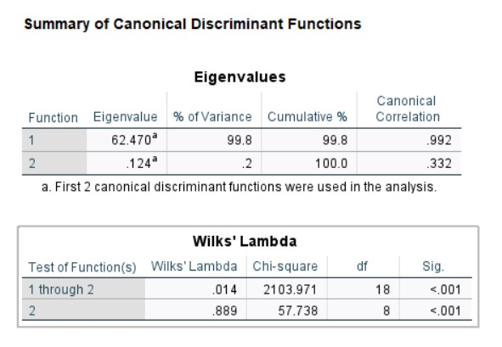

# Interpretation of Loyalty Segments

High-loyalty customers perceive variety, price, parking, and rewards extremely positively and are highly engaged with the brand.  
Medium-loyalty customers show moderate satisfaction and are reachable with targeted offerings.  
Low-loyalty customers rate most features poorly but respond better to advertising and servicescape.

# Strategic Recommendations

* 1. Launch “Thali Tailored” - Customizable Meal Experience

Introduce a station with build-your-own thalis featuring regional specialties and health-conscious options.

* 2. Premium Parking Pass and Family Service Pods

Offer fast-lane parking, shaded zones, valet service, and clean restrooms to elevate convenience.

* 3. Driver+ Loyalty Tracker

Digitally track visits with automated tiered rewards and referral incentives.

* 4. “Dhaba Stories” Ad Campaign

Use geo-targeted reels featuring Mama Yadav and customers to build emotional connection.

* 5. Servicescape Makeover + Cultural Nights

Introduce folk-themed decor and live music on weekends to enhance ambiance.

# Deeper Insights into Loyalty Segments

The Discriminant Analysis shows a strong ability to segment customers based on their perceptions of the restaurant's value offerings. High-loyalty customers are deeply engaged due to consistent satisfaction across key factors like food variety, parking convenience, and pricing. Their positive experience is reinforced by functional benefits (parking, gifts) and emotional connection (familiarity, tradition). This signals the importance of bundling tangible benefits with sentimental branding.  
  
Medium-loyalty customers are likely at a decision point — they perceive some value but may lack novelty, emotional resonance, or incentives to continue. They’re the most vulnerable to competitor poaching, especially from high-visibility QSR brands.  
  
Low-loyalty customers represent either first-timers or dissatisfied past users. Their relatively higher response to advertisement and servicescape suggests initial curiosity or interest, but poor follow-up experience (price sensitivity, lack of personalized rewards) may be causing drop-off. The brand needs to capture these customers by addressing expectation-reality gaps and turning curiosity into habit.

6. Launch Seasonal Promotions (Linked to: Variety & Advertising)

* The case mentions **peak vs. off-peak seasons**.
* Offer **seasonal specials** during low-traffic months (e.g., winter milk-based drinks, summer coolers).
* Use menu innovation to maintain interest among Medium-loyalty customers.

7. Improve Waiting Experience with Live Updates (Linked to: Service Quality)

* The graph shows **clear separation of loyalty groups**.
* Use this to **design targeted messaging**:
  + High-loyalty → “Thank You” campaigns, insider offers.
  + Medium-loyalty → Conversion incentives, personalized SMS.
  + Low-loyalty → First-visit discounts, retargeted ads.
* SPSS classification results can guide **CRM segmentation.**

# Conclusion

Discriminant Analysis revealed that loyalty is driven by variety, pricing, parking, and rewards. Low-loyalty customers are drawn by ads and ambiance but not retained. By applying these findings, Shiva Tourist Dhaba can convert casual visitors into loyal patrons and stand out among highway competitors.Appendix: SPSS Outputs

## Tests of Equality of Group Means



## Structure Matrix (Function 1)



## Canonical Discriminant Functions and Centroids



## Classification Results



## Group Means

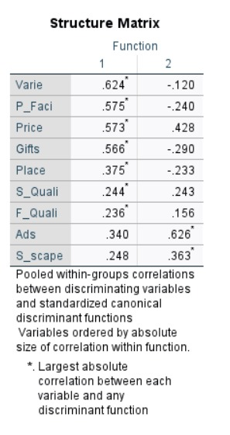

## Eigenvalues and Canonical Correlation

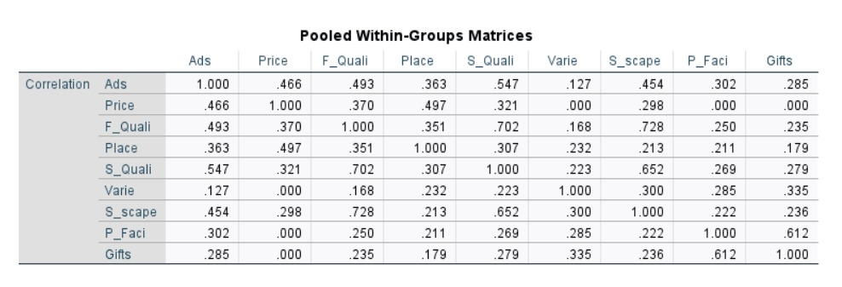

## Group Means for Loyalty Segments

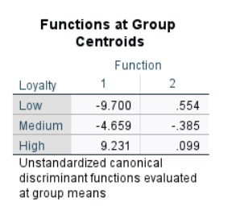

## References

Malhotra, N. K., & Dash, S. (2010). Marketing research: An applied orientation (6th ed.). Pearson Education.

Hussain, A. Z., Samiran, M., Saleh, H., & Hasnan, N. (2017). The effects of parking convenience towards customer retention in Gurney Drive, Penang. *International Academic Research Journal of Social Science, 3*(1), 1–5. https://www.iarjournal.com/wp-content/uploads/IARJSS2017_1_1-5.pdf